Create table Users:
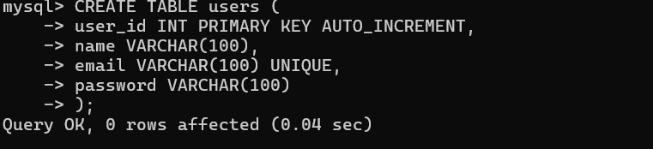
Insert data into user:
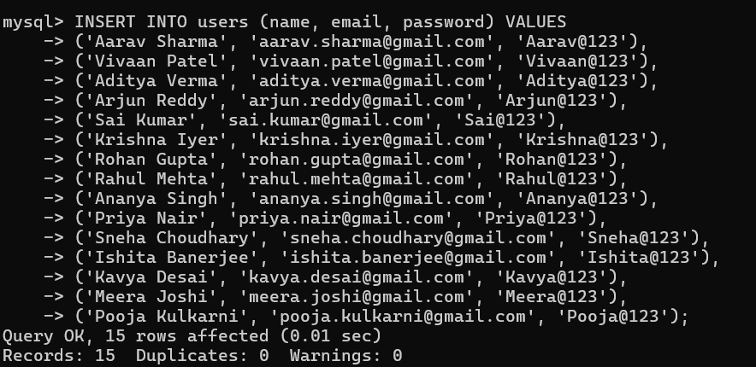

Create table Movies:
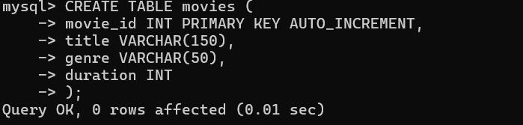
Insert data into Movie:
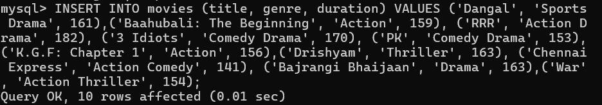

Create Table Shows:
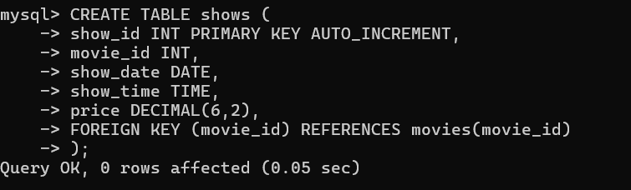
Insert data in Shows:
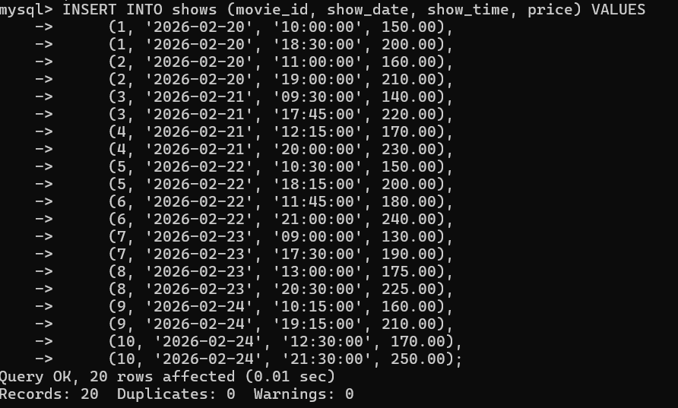

Create Table Seats:
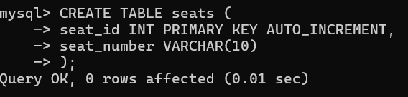
Insert data into Shows:
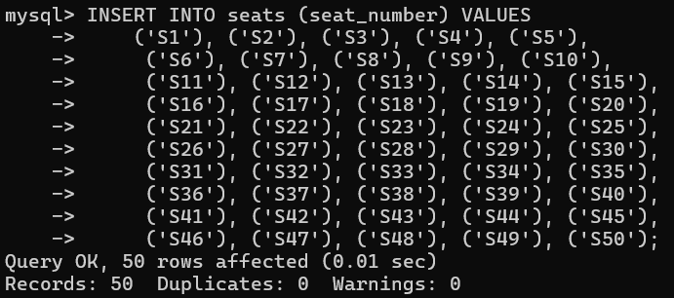

Create Table Bookings:
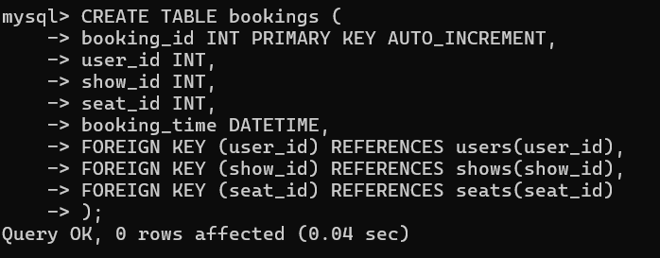
Insert data into bookings:
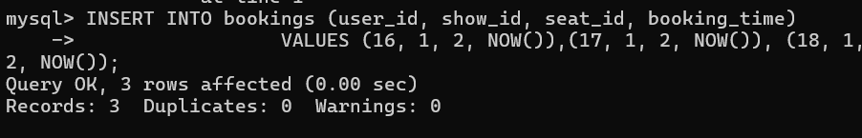

List all movies:
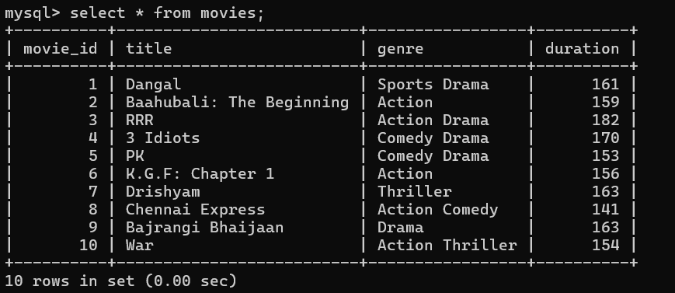

List all movie:
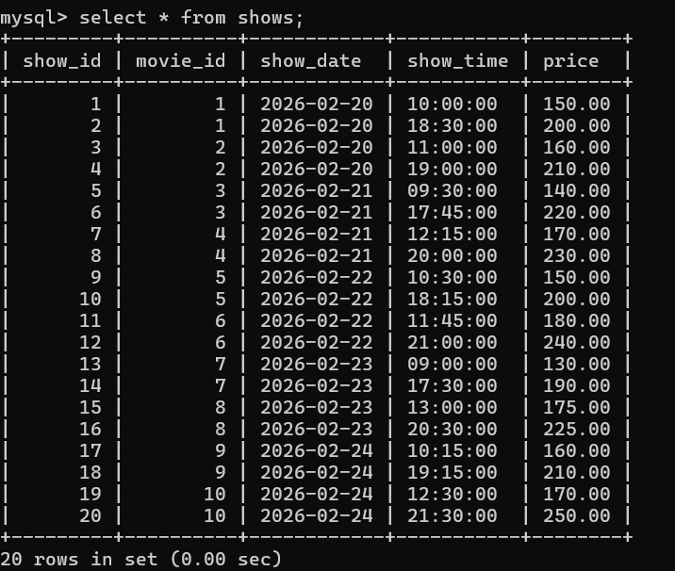

List shows for a movie:
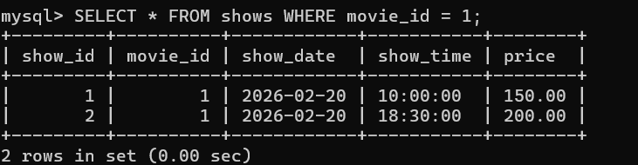

Find available seats:
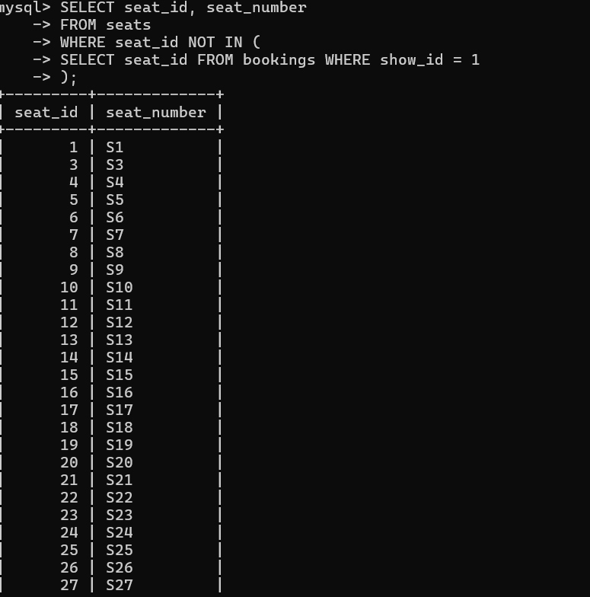
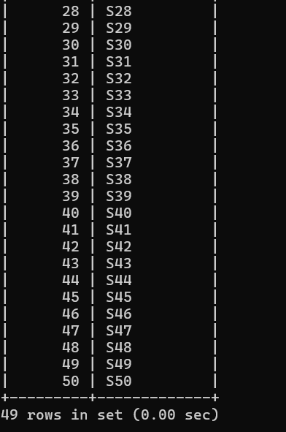

View user booking history:
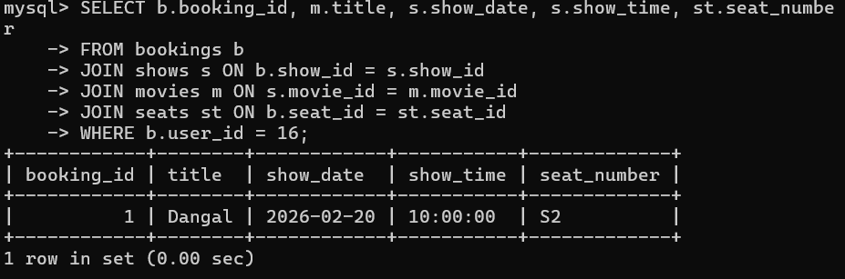

- Write a query to display all users stored in the system.

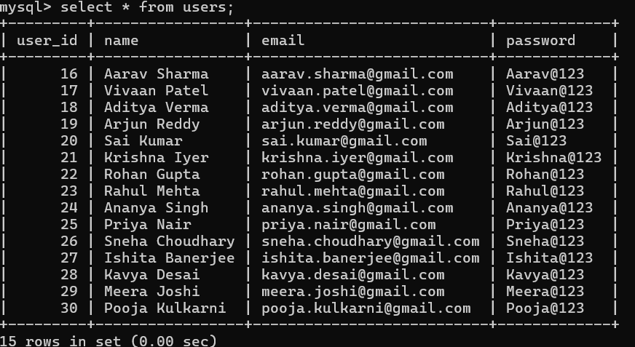

- Write a query to list all movies in the movie table.
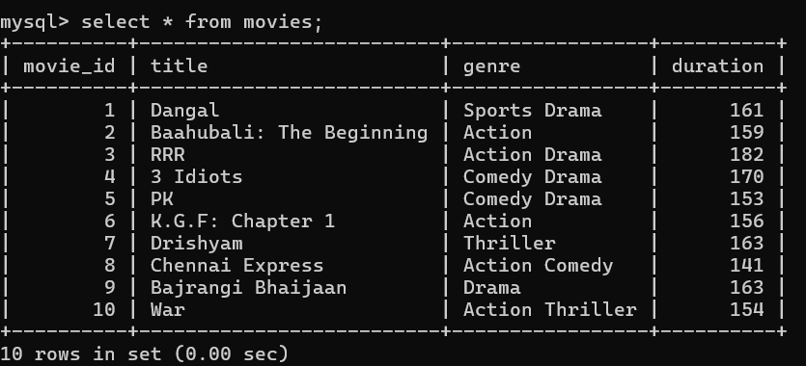

- Write a query to display all available shows.
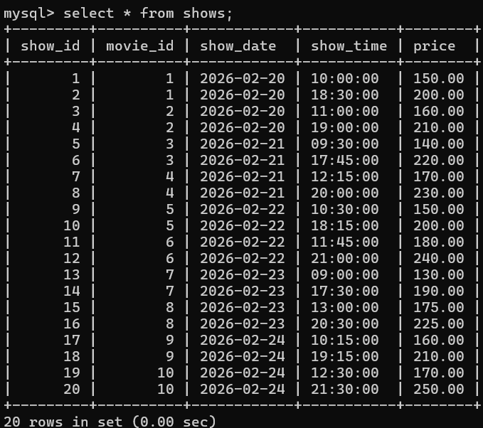
- Write a query to fetch details of a movie using its movie_id
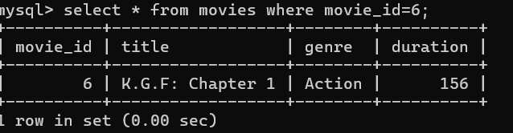
- Write a query to list all shows of a particular movie.
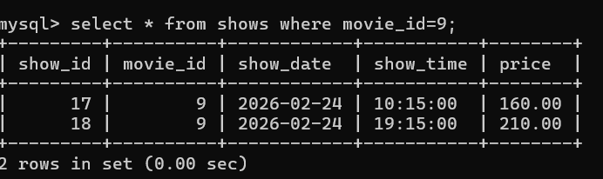
- Write a query to list all seat numbers from the seats table.
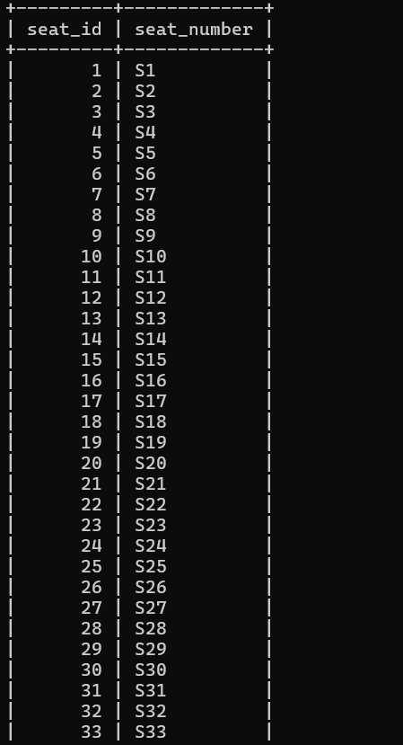
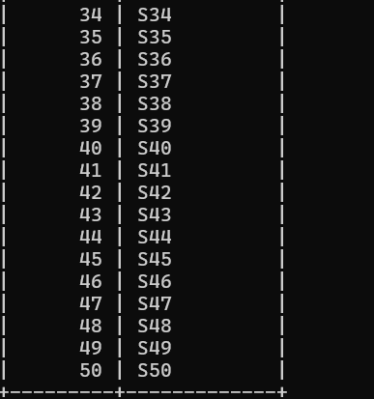
- Write a query to find available seats for a specific show.
SELECT SEAT_NUMBER FROM SEATS WHERE SEAT_ID NOT IN(SELECT SEAT_ID FROM BOOKINGS WHERE SHOW_ID=6);

- Write a query to display all booked seats for a specific show.
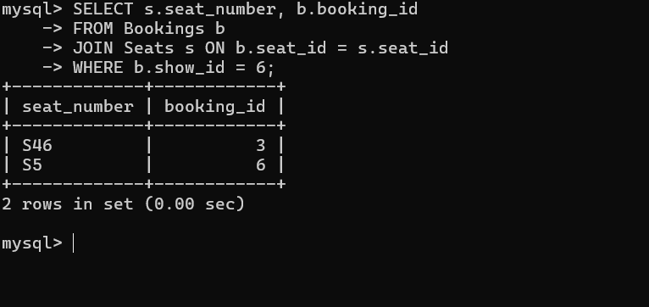

- Write a query to insert a new user into the users table.
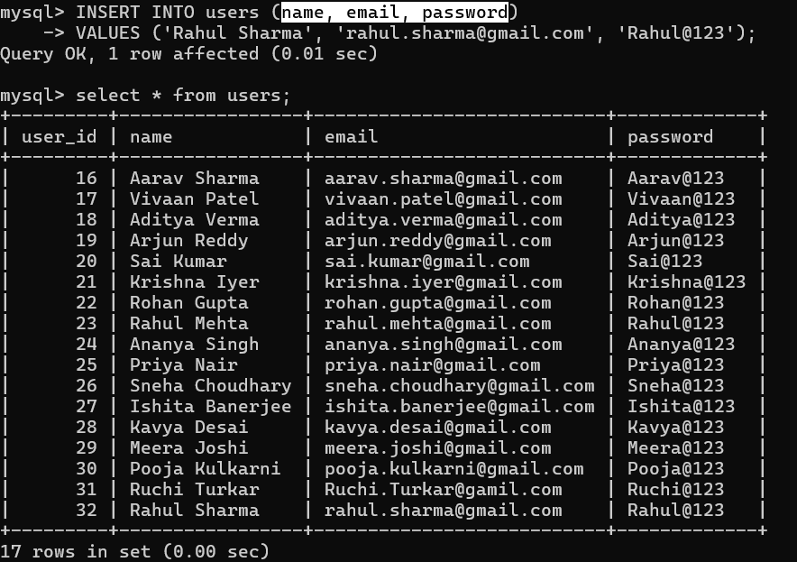
- Write a query to insert a new movie into the movies table.
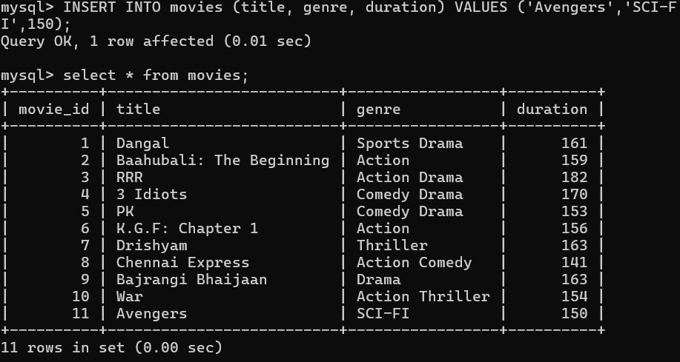
- Write a query to insert a new show into the shows table.
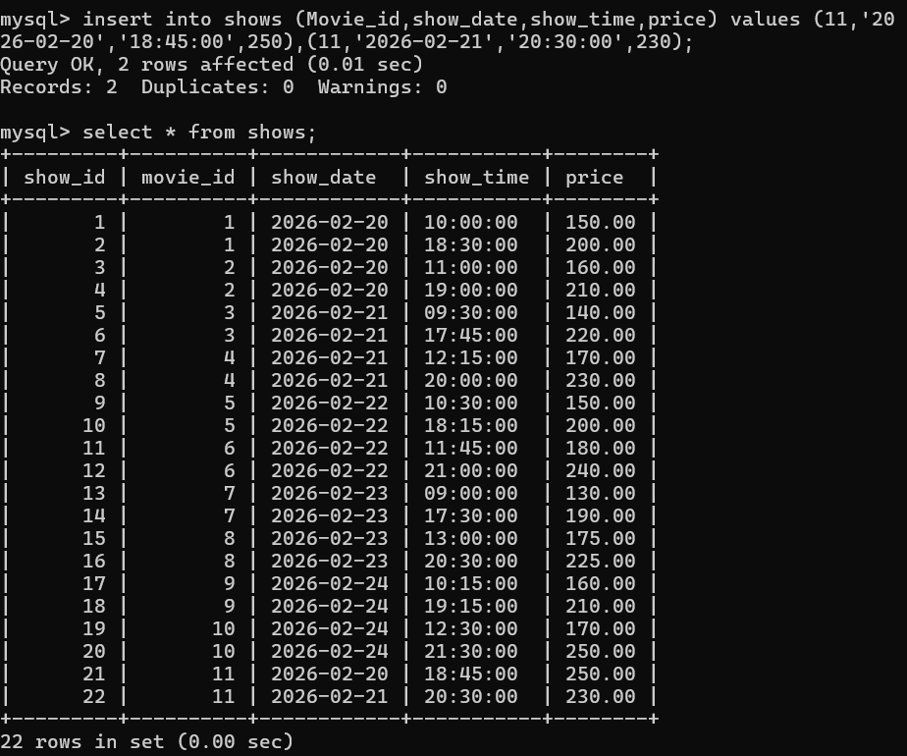

- Write a query to add a new seat to the seats table.
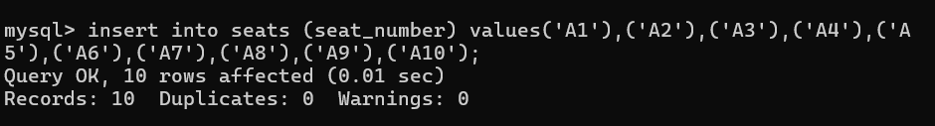
- Write a query to book a ticket for a user.
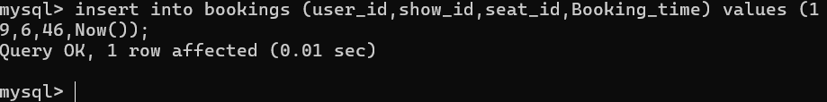
- Write a query to display all bookings.
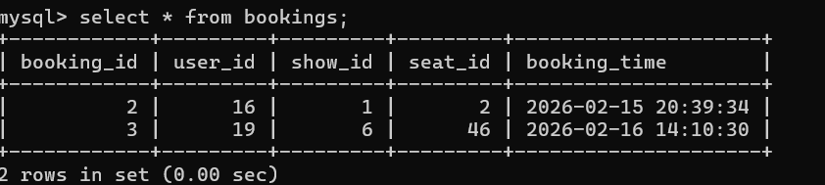
- Write a query to display booking history for a specific user.
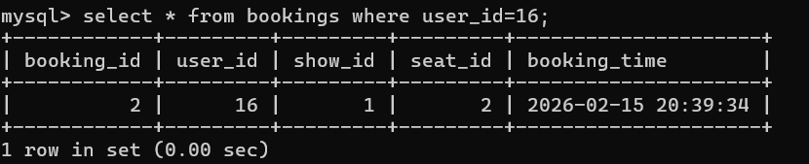
- Write a query to count total bookings for a specific show.
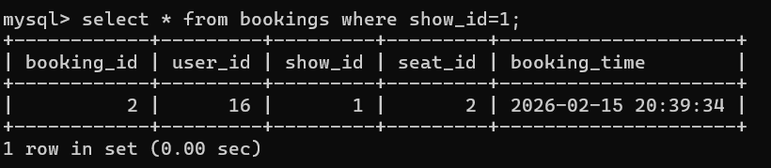
- Write a query to count total bookings for a specific movie.
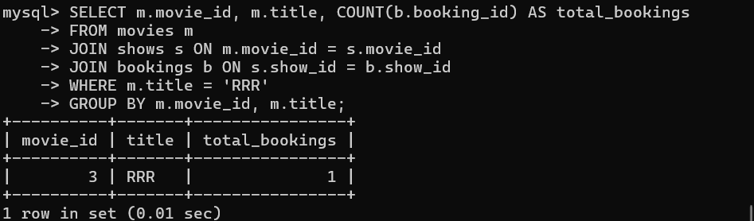

- Write a query to find all movies of a specific genre.
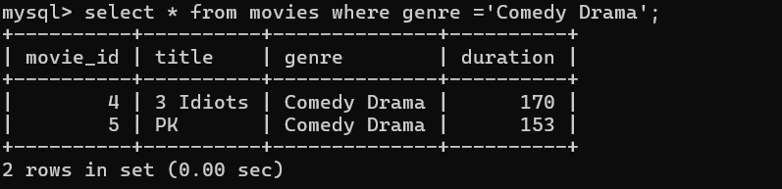
- Write a query to update the duration of a movie.
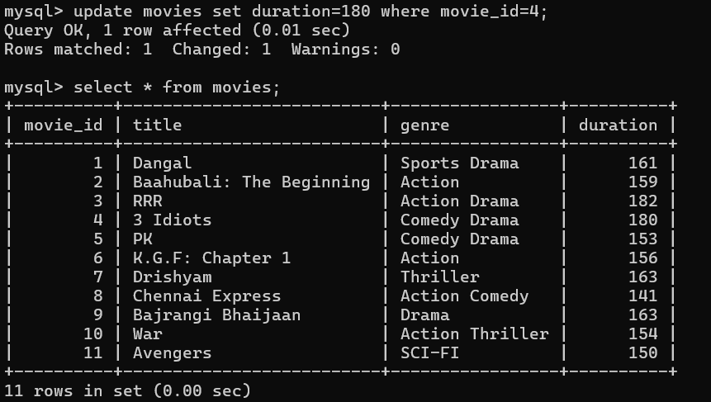
- Write a query to update the seat number for a given seat_id.
- Write a query to delete a specific booking record.
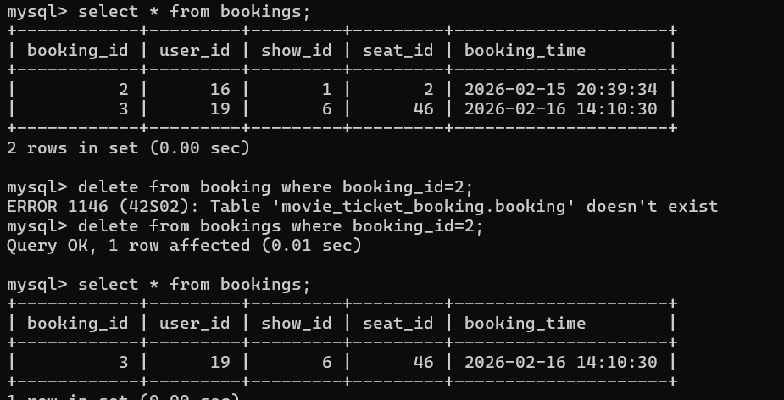
- Write a query to delete a movie from the movies table.
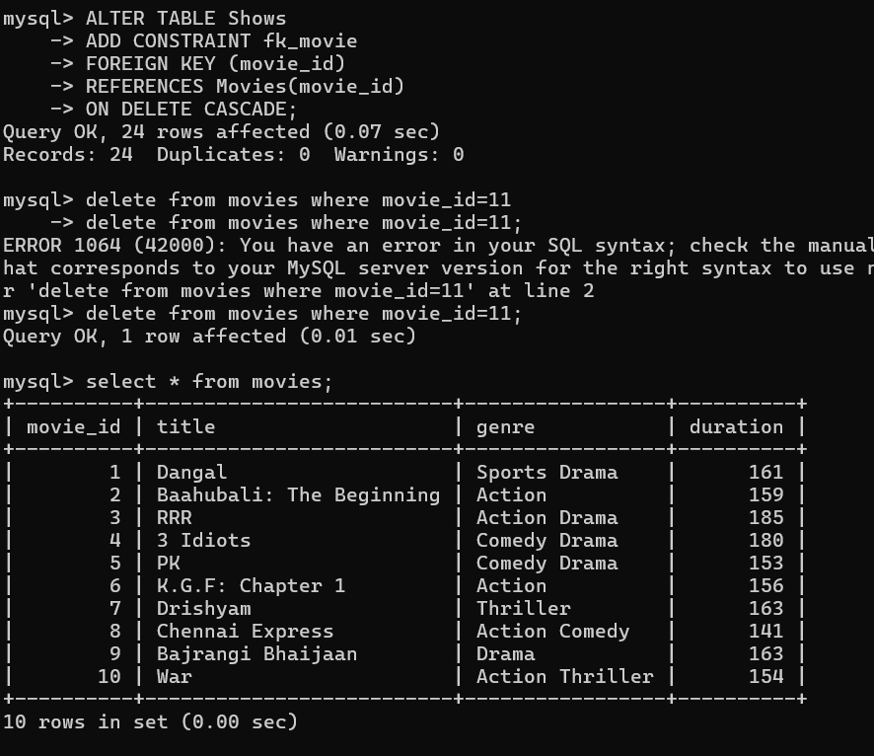
- Write a query to list movies longer than 2 hours.
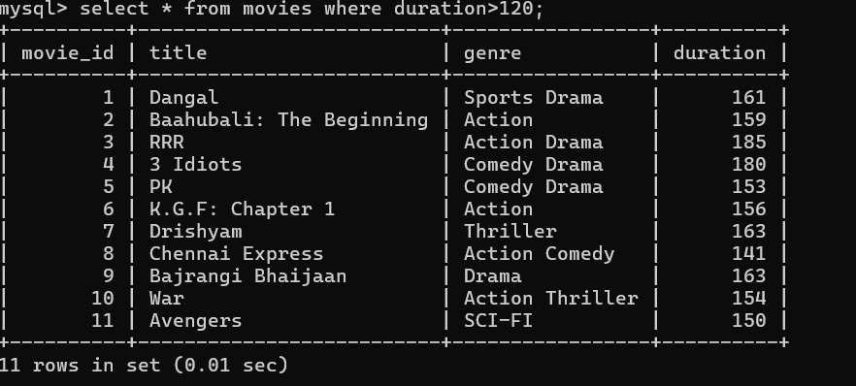
- Write a query to find shows scheduled for today's date.
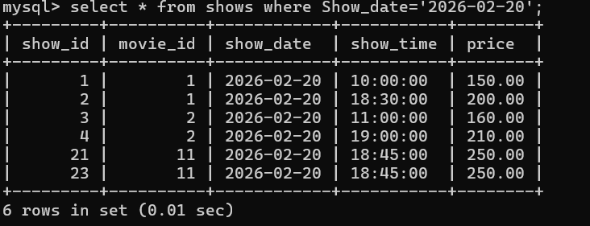
- . Write a query to list upcoming shows sorted by date and time.
